Ender’s Game, by Orson Scott Card: Chapter 1 – 11 Quiz
(***DO NOT WRITE ON THIS TEST – USE THE PROVIDED ANSWER CARD***)
- What is Ender’s real name?

- Peter Wiggin
- Hyrium Graff
- Andrew Wiggin
- Bonzo Madrid

- Who is Peter?

- An enemy Ender encounters in the fantasy game.
- Ender’s brother.
- The commander of Salamander Army.
- An I.F. instructor.

- What is a bugger?

- A nickname Ender’s sister has for him.
- The slang term used in reference to the alien species, Formic.
- The slang term used by students when someone makes a mistake.
- What Peter calls Ender when he is being cruel.

- Graff says it isn’t the fight that earned Ender an invitation to enter Battle School, it was why he fought as he did. Why is this important?
- The I.F. wanted to be sure Ender was vicious enough to defeat the buggers without allowing compassion to get in the way.
- The I.F. wanted to be sure Ender had fought out of self-preservation and not out of cruelty in order to be certain he was not dangerous and vicious like Peter.
- The I.F. was gathering information for a trial against Ender for the murder of Stilson.
- Graff wanted to make sure Ender was easily manipulated by his emotions.
- Why does Graff single Ender out and make the other boys dislike him?
- Graff was trying to make Ender feel better about going to the Battle School, but it backfired on him instead.
- Graff was trying to isolate Ender from the other boys to help build his character as a commander.
- Graff was angry Ender had broken the other Launchies arm during launch.
- Graff thinks Bonzo is a better commander and is trying to help Bonzo set Ender apart from the other soldiers.

- Who do the I.F. observers feel is the weak link?

- Peter
- Alai
- Valentine
- Dink

- Why are Ender’s parents considered to come from non-compliant families?
- Ender’s parents had a third child without government approval.
- Ender’s parents both came from families that rebelled during the bugger wars.
- Ender’s parents both came from religious families that refused to adhere to the child limitation laws.
- Ender’s parents were both recruited into the Battle School program but their families refused to allow the government to take them from Earth.
- How long has it been since the last war?

- 1000 years
- 100 years
- 50 years
- 80 years

- Who does Graff say is the only boy with brains on the launch?

- Bernard
- Ender
- Bean
- No one – He says they are all going to get iced in a week.

- What does it mean to “ice out”?
- When a student dies as a result of a complication when removing the monitor.
- To be promoted within the Battle School rankings.
- To be sent back to Earth.
- To be completely frozen during battle in the Battle Room.
- In the fantasy mind game, how does Ender win against the Giant?
- He finally chooses the drink that is not poisoned.
- He releases the snake and the snake devours the Giant.
- He kicks over both the glasses of poison and the poison eats through the Giant’s flesh.
- He kicks over both glasses of poison and then jumps onto the Giant, borrowing into his eye.
- Who trained Ender how to shoot?

- Petra
- Bonzo
- Dink
- Alai

- How are the injuries listed in the medical report after the fight with the practice group in Null-G?
- Accidental Collision in Null-G
- Unscheduled Army on Army Assault in Null-G
- Unscheduled Med-Bay Practice in Null-G
- Accidental Breech in Airlock of Null-G
- What does Valentine send into space on Ender’s birthday?

- A rocket
- Fireworks
- Smoke
- Prayers

- In what army does Ender command a toon at age nine?

- Salamander
- Rat
- Dragon
- Pheonix

- Who traveled to Earth and went to the school to talk with Valentine?

- Dink Minker
- Ender
- The Polmarch
- Col. Hyrium Graff

- How many of Ender’s night practice soldiers are in his new army?

- All of them
- None
- Only 10
- Just Alai

- What colors are assigned to Dragon Army?

- Gray Orange Gray
- Black Red Black
- Blue Red Black
- Red Brown Orange

- Who does Ender single out during practice?

- Alai
- The new Lanchies
- Bean
- Himself

- Why can’t Ender practice during free time with his friends?
- His responsibilities as the new commander of Dragon Army have kept him from continuing the evening practice groups.
- He was hurt by Alai and Shen being so close and decided he did not want to be around them anymore.
- Anderson has put the battlerooms on a schedule and ruled Ender must practice only with his own army.
- Graff took him to Earth with him when he went to visit with Valentine.
- Who does Ender want to defeat?

- The buggers
- Peter
- Bonzo
- The teachers; His enemies

- How many battles does Ender’s army fight in seven days?

- None
- 4
- 8
- 1

- Whose strategy does Ender study in the films?

- The buggers
- Dink Minker
- Mazer Rachham
- Col. Graff

- What does Ender ask Bean to command?
- Ender asks Bean to command Dragon Army if something happens he is frozen in battle.
- Ender asks Bean to command a special force, an independent unit within the army; he sees the same independent and inventive thinking in Bean that he learned from Dink.
- Ender asks Bean to learn how to command his soldiers; he does not think Bean knows how to lead his toon efficiently.
- Ender asks Bean to command Salamander Army; he knows Graff is about to offer it to him and Bean has made it known he does not want to command an army.
- How many men will be in the special unit?
- Bean and one other soldier
- Bean and half the army
- Bean and five other soldiers
- Bean and all the other Launchies in the army

***At this point, you may get your notes out to help you double-check your answers.***

You MAY NOT use the book or any copies of the text – notes, packets, and graphic organizers only.

Name:_______________
Date:__________/Period:_____
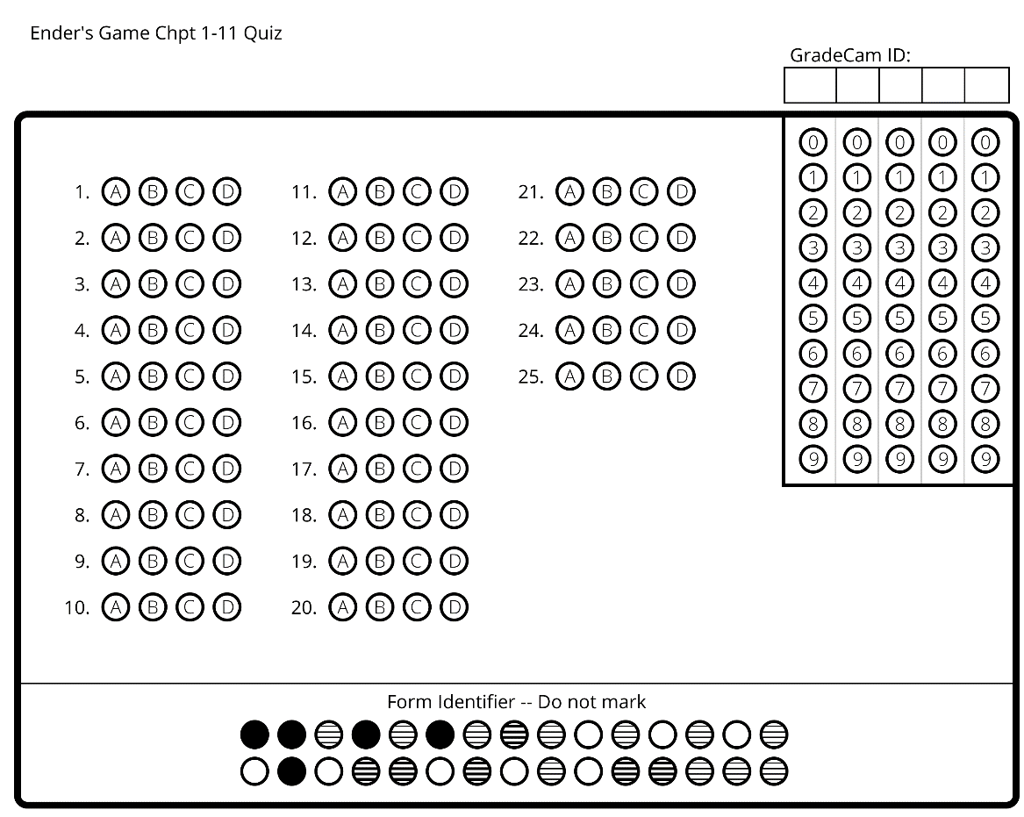

Name:_______________
Date:__________/Period:_____
Ender’s Game: Chapter 1-11 Quiz (KEY)

- C
- B
- B
- B
- B
- C
- C
- D
- B
- C
- D
- A
- A
- C
- D
- D
- B
- A
- C
- C
- D
- C
- A
- B
- C

